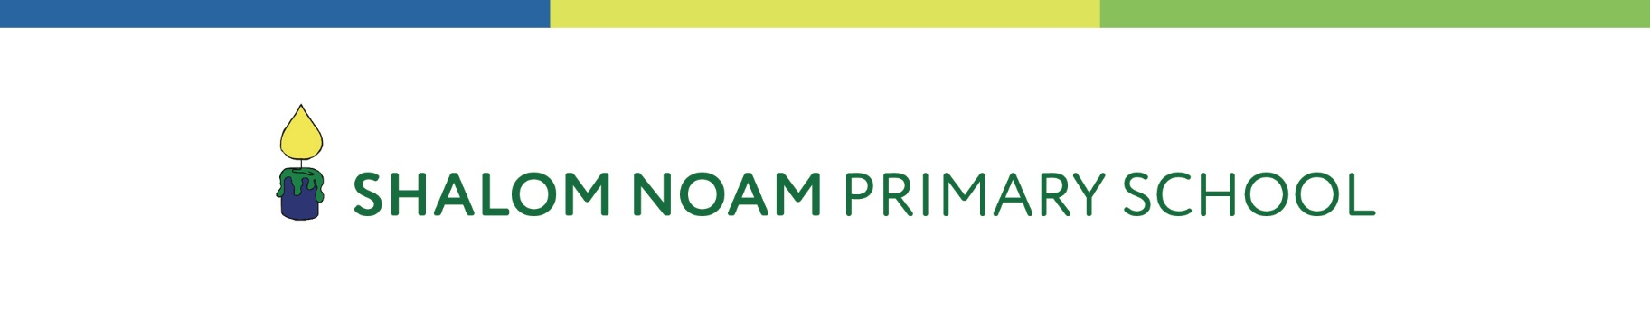

Is your child due to start
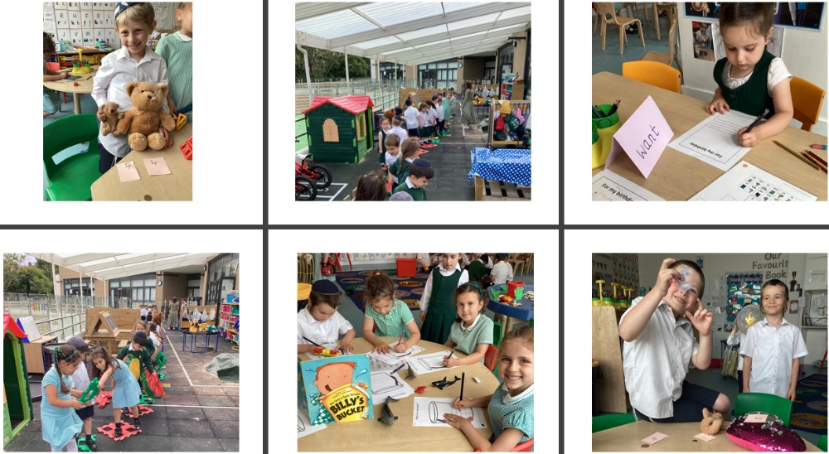
Nursery or Reception in September 2024?

We would like to welcome you to our Open Day on
Tuesday 31 October 2023.

There are two options:
- Visit the school in person (9.30am): Meet the Headteacher, Head of Kodesh, governors, staff and some of our delightful pupils. Join a tour of the school and see learning in action.
Please email office@shalomnoam.org to enlist for the tour.

- Virtual tour of the school on Zoom (8.00pm)
Please register by emailing office@shalomnoam.org.

Please ensure you respond by Tuesday 24 October 2023
If you have any questions, please do call the school office:
020 8908 9491 or email office@shalomnoam.org

